**Fast Reports Installation Guide**

1. Extract FastReports.rar , on the extracted folder, install FastReport.Net.2020.1.6.msi



1. Once installed, close the Fastreports app if its open. Go to

C:\Windows\Microsoft.NET\assembly\GAC_MSIL\FastReport\

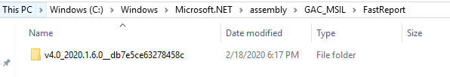

Inside the folder, replace **FastReport.dll** with the FastReport.dll on the crack folder.

1. Go to Program Files (x86) > Fast Reports > Fast Report Trial , delete all files inside **Nuget** folder, then copy the contents of Crack > Nuget to Program Files (x86) > Fast Reports > Fast Report Trial > Nuget
2. Copy Framework 2.0 and Framework 4.0 from Crack to Program Files (x86) > Fast Reports > Fast Report Trial and overwrite the files.
3. Open up **Visual Studio**, then go to **Tools > Nuget Package Manager > Packager Manager Settings**
4. Select **Package Sources**

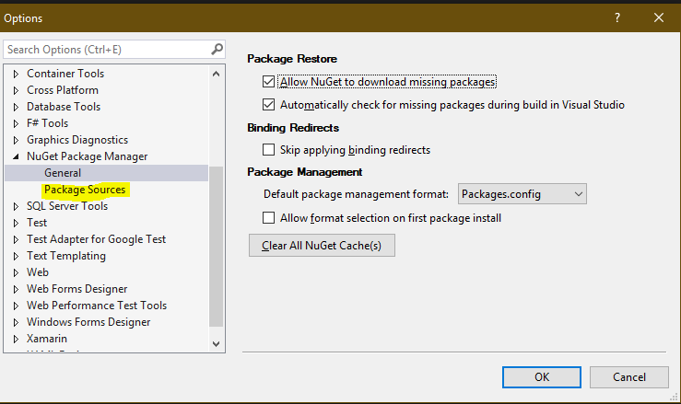

1. Click the **Green Plus Icon** on the topmost right part of the window, on the **Name** field, type in “FastReports”**,** then click the “…” button and select this folder C:\Program Files (x86)\FastReports\FastReport.Net Trial\Nugets , click Update then OK

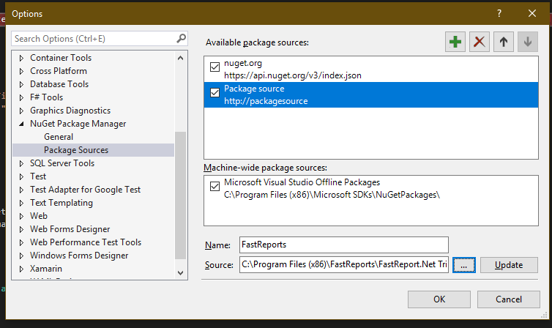

1. On your Solution Explorer, right click on your Main Project where Fast Reports need to be installed, select **Manage Nuget Packages**
2. On the Nuget Package Screen, click the dropdown field on the rightmost part of the window, then select **Fast Reports** .Install **FastReport.Core and FastReport.Web** (note : If you have other FastReport installations ie FastReport.OpenSource uninstall it)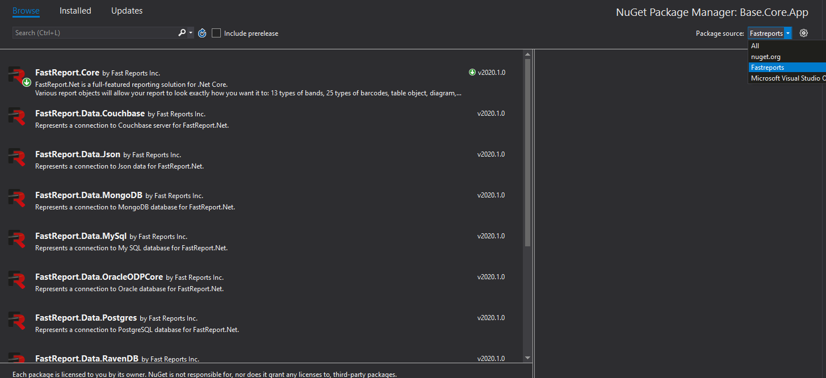
3. Rebuild your code and run it, you should be seeing more import options on the web report now 